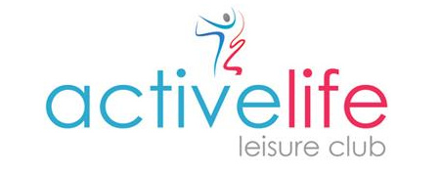

Club Opening Times
Monday – Friday 06:30 – 21:00
Saturday 08:00 – 18:00 (pool opens at 08:30 & closes at 17:00)
Sunday 08:00 – 18:00 (pool opens at 08:30 & closes at 17:00)

Adult Only Swimming
Monday – Friday 06:30-10:15*/12:30-14:00/18:30-21:00*
Saturday & Sunday 08:30 – 10:00 (pool shared with swimming lessons)
*Aquacise in the pool Monday & Friday 08:45 – 09:30 & Wednesday 18:30 – 19:15

Family Swim Times
Monday – Friday 10:15 - 12:30 & 14:00 - 18:30
Saturday & Sunday 10:00 – 17:00

Last entry to the pool & gym is 45 minutes before closing

